From: Lee Kok Cheng [mailto:kok-cheng.lee@dbschenker.com]
Sent: Monday, 22 February, 2010 10:07 AM
To: pei-fong.chan@dbschenker.com
Subject: Additional info for KPI report - Urgent
Hi Pei Fong,
As Kohata have requested additional information to be present in our Weekly KPI report. Please see slides 7 and 8 and come up
With an application for retrieval. If possible , similar with the Aust fomat. Call me if you have doube.

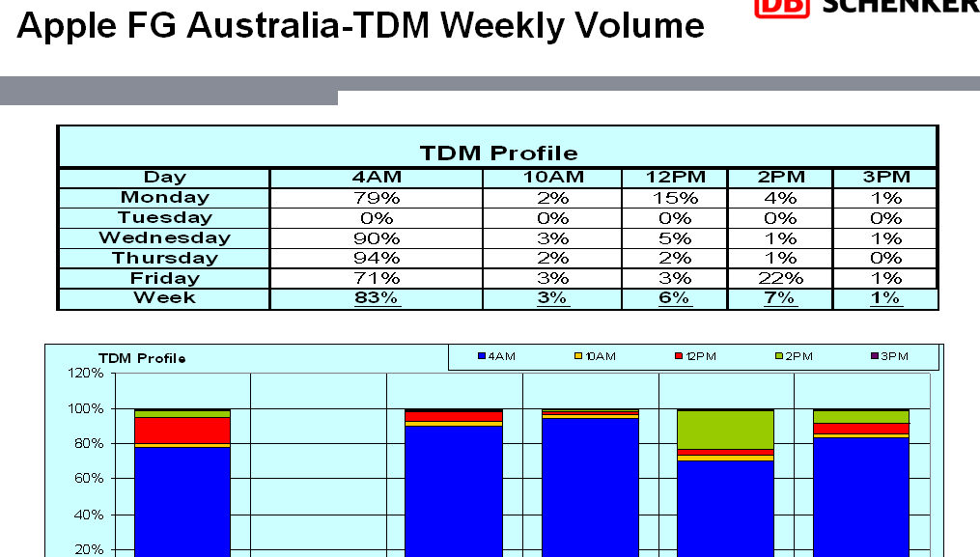

Hub Changes:
8.Report - > KPI01. Order TDM
